317976 | EUP | WAT | PL02 | A
C:\Users\whi36085\Desktop\Motts\Motts Planning forum\pathfinder planning docs\Guidance Note -Generating P6 S-Curves in Excel.docx
20 August 2013
Guidance Note: Generating P6 S-Curves via Excel
Guidance Note: Generating P6 S-Curves via Excel
August 2013
Mott MacDonald, 10 Fleet Place, London EC4M 7RB, United Kingdom
t +44 (0)20 7651 0300 f +44 (0)20 7651 0310 w www.mottmac.com

Issue and revision record
This document is issued for the party which commissioned it and for specific purposes connected with the above-captioned project only. It should not be relied upon by any other party or used for any other purpose. | We accept no responsibility for the consequences of this document being relied upon by any other party, or being used for any other purpose, or containing any error or omission which is due to an error or omission in data supplied to us by other parties.  This document contains confidential information and proprietary intellectual property. It should not be shown to other parties without consent from us and from the party which commissioned it..
Revision | Date | Originator | Checker | Approver | Description | Standard
Rev A | 20/08/13 | G Whitehead | S W Plummer | A Hiney | For Issue to Pathfinder

Contents
Chapter Title Page
Executive Summary i
1. Pre-Requisites 1
2. Primavera Settings 2
3. Generating all curves other than “Forecast Cost” 4
4. Generating the “Forecast Cost” Curve 9

Executive Summary
“S-curves” are a common report tool to display achieved and forecast progress on a project. The name derives from the common shape of such progress graphs, as projects typically start off slow, speed up in the middle, and slow down towards the end.

There are a number of s-curves that can be generated:
- Planned Value curve, (aka Baseline curve, Target curve, Planned work curve). –Shows the profile of cumulative work done expected, as per the Baseline programme
- Earned Value curve (aka VOWD curve, Achieved work curve). –Shows the profile of cumulative work done to date, as per the latest updated programme
- Forecast Value curve (aka forecast work curve, Remaining value curve, remaining work curve). –Shows the profile of cumulative work forecast for the future, as per the latest updated programme
- Actual cost curve –Shows the profile of cumulative costs actually incurred to complete the work done to date, as per the latest updated programme
- Forecast cost curve –Shows the profile of cumulative costs which are forecast to be spent in order to complete the remaining work, as per the latest updated programme

All of these can be measured in terms of cost or man-hours. This procedure will cover both options.

Pre-Requisites
The different curves available have different pre-requisite requirements:

- Planned Value curve. –Requires a baseline which has been loaded with costs and/or resources. This baseline should be assigned as the “Project Baseline” via the Project>Assign Baselines menu.
- Earned Value curve. –Requires a baseline as above.
- Forecast Value curve –Requires the current programme to have budgeted costs and/or resources as per the baseline described above (plus any approved changes to the budget –e.g. from a client variation order)
- Actual cost curve. –Requires actual costs and/or resources to have been entered into the current programme. (NB: often the actual cost profile is already available in spreadsheet format from timesheet or cost capture systems. In that case, there is clearly no need to enter it into Primavera in order to generate the Excel curve)
- Forecast Cost curve –Requires one of the following:
  - Remaining cost and/or resource data to be manually entered into the current programme
  - Agreement that this curve ignores the “remaining cost” data from the activities, and instead is calculated using the formulae PF*(Budget at Completion-Earned Value)
(NB: If option (b) is chosen with a PF value of 1, then this curve will be identical to the Forecast Value curve above –no need to generate them both. Also, this data is often already available in spreadsheet format from a Project QS or Cost Engineer. In that case, clearly no need to generate it via Primavera)

Primavera Settings
Ensure the following settings are applied to Primavera via the Admin>Admin Preferences> Earned Value menu:

- Technique for computing performance percent complete: As per project requirements. By default, activity % complete should be used.
- Technique for computing estimate to complete (ETC): PF=1
- Earned value calculation: Budgeted values with current dates.

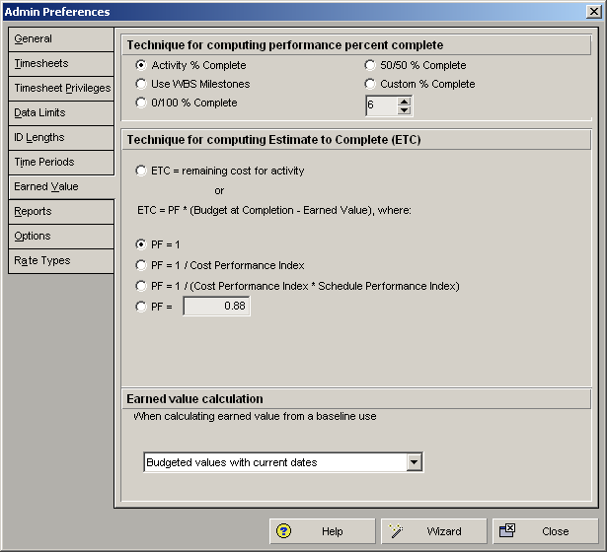

In addition, items (1) and (2) above can be set differently for individual WBS elements. Ensure the settings for all WBS elements are as per above via the Project>WBS>Earned value menu option

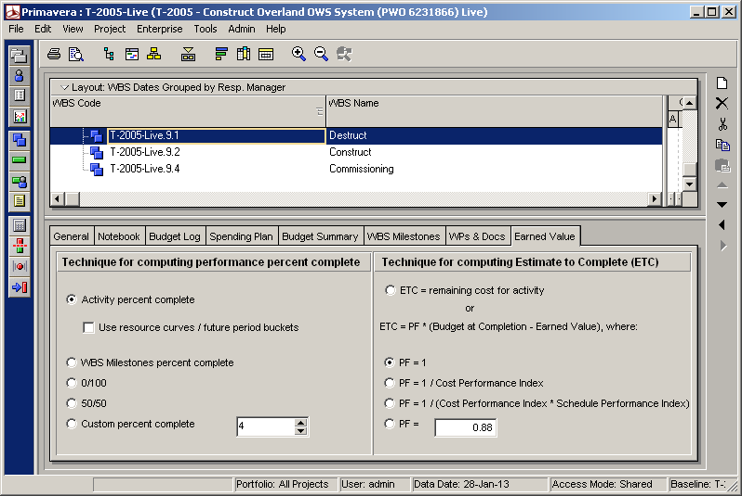

Generating all curves other than “Forecast Cost”
- Open the current programme, and ensure no filter is applied
- Right-click on the right-hand pane and select “timescale”. Ensure the appropriate “Date Interval” option is selected, dependant on what interval you want your S-curves based on (e.g. for S-curves updated weekly, select “Month/Week):

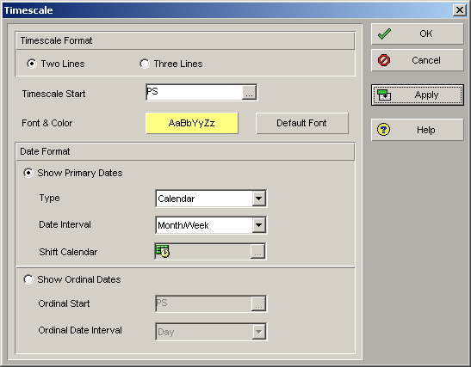

- Got to View>Show on bottom>Activity usage spreadsheet
- Right-click on the bottom-right pane, and select “Spreadsheet fields”. Select the appropriate fields from the “cumulative” section, dependant on which curves you want to generate, and whether you want to measure in terms of cost or man-hours (or both):
  - Planned Value: Cum Planned Value Cost or Labour Units
  - Earned Value: Cum Earned Value Cost or Labour Units
  - Forecast Value: Cum At Completion Total Cost or Cum Estimate At Completion –Labour Units
  - Actual cost: Cum Actual Cost or Labour Units:

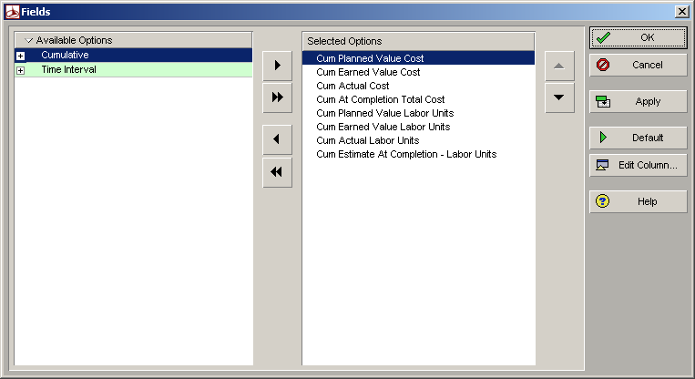

- Collapse the activities in the bottom-left pane to show only the highest project-level summary:

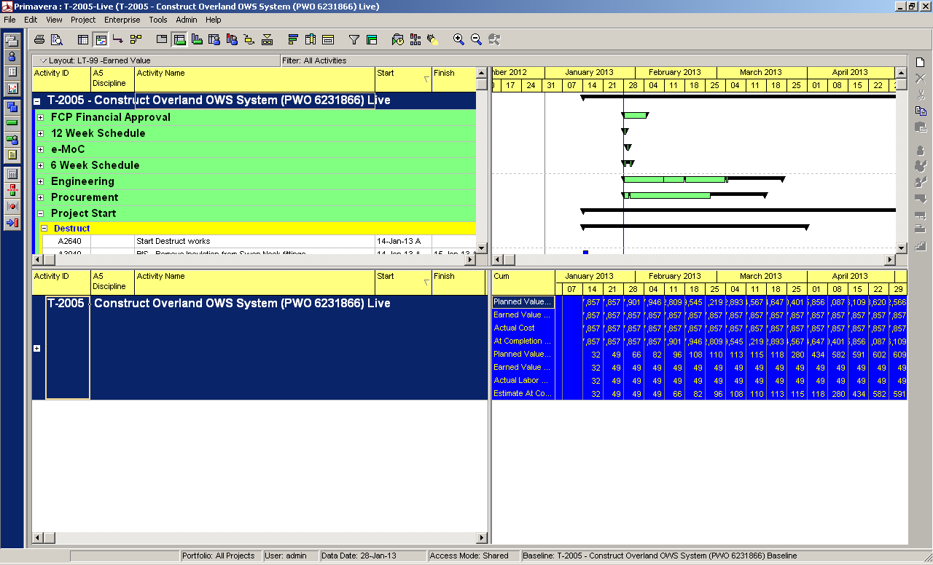

- Left click anywhere in the spreadsheet section of the bottom-left pane and use CRTL+C to copy
- Open up a blank excel spreadsheet and CTRL+V to paste the data:
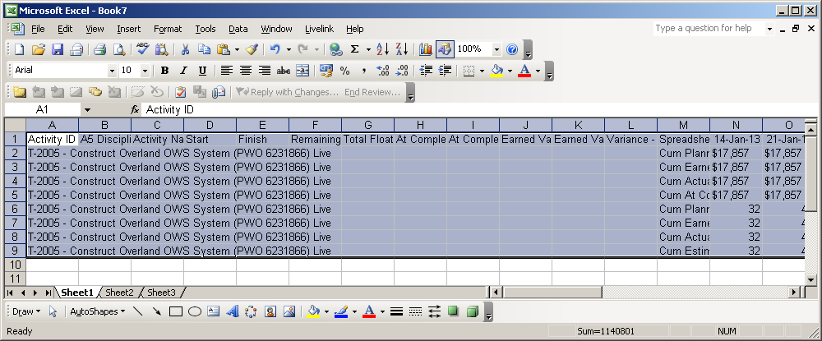
The initial columns in excel relate to the columns you have showing in your standard Primavera programme (in the case of the screen shot above: Columns A to L). Ignore them. –We are only interested in the right-hand columns beginning with “Spreadsheet field”

- For the cost-related data, it will have copied as text with currency symbol. For the graph to work, you will need to convert the data into numbers rather than text. Copy & paste the relevant rows, and apply the following formulae to the copied cells:
=IF(N2=0,"",(RIGHT(N2,LEN(N2)-1)+0))
(where N2 is the cell with the text-based data to be converted):

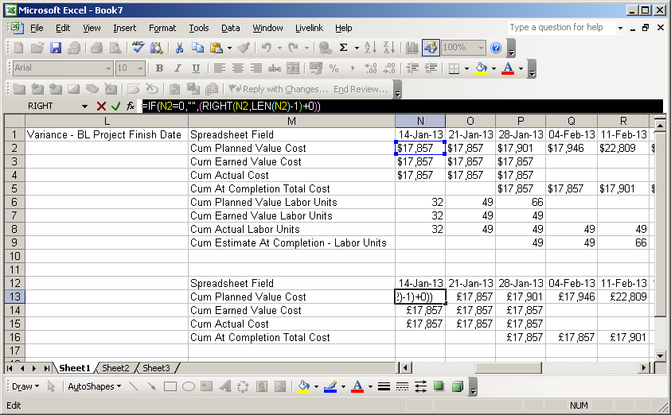

- Make the following amendments to the data:
  - For Cum Earned Value Cost/Labour, and for Actual Cost/Labour: delete all data for periods WHOLLY AFTER the current data date
  - For Cum At Completion Cost/Labour: delete all data for period WHOLLY BEFORE the current data date.

- Use the Excel graph option to draw your S-curves. You may want to re-name the “Spreadsheet field” entries to give your graphs more user-friendly labels

Generating the “Forecast Cost” Curve
This curve is generated in exactly the same way as the “Forecast Value” curve above.
The only difference is that you need to set the “Technique for computing Estimate to Complete” to either “ETC = remaining cost for activity”, or the appropriate PF calculation. Be sure to do this both in the admin settings, and the WBS elements.

